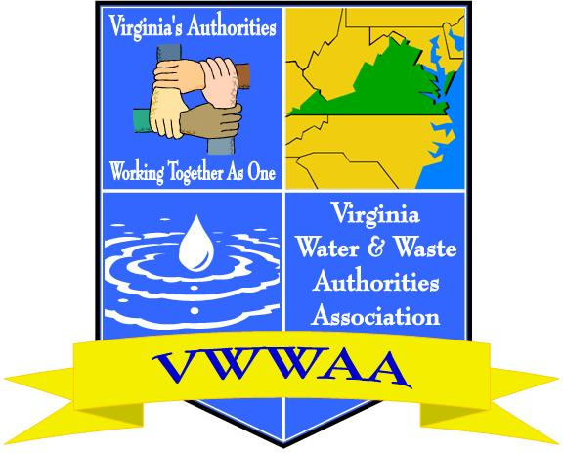

VWWAA New Member Membership Form

Authority or Company Name

Address

Phone Number

Name of Contact

Email Address for Contact

Second Designee

Email Address for Designee

Process:
Please email this completed form to Jewell Lilly at jlilly@loudounwater.org

Upon receipt of this completed form, your information will be entered into the VWWAA database. VWWAA communicates via email to conserve resources and reduce the impact on our environment.

An invoice for annual dues will be generated to the contact email address to initiate your membership. After that, invoices for annual dues will be sent out during the first quarter of each year.

THANK YOU
For choosing to be a part of the Virginia Water and Waste Authorities Association and supporting the important work we do to impact legislation that affects Authorities.

